General Instructions - DELETE BEFORE CREATING FINAL REPORT
- The report should be not more than 2-5 pages in length - only brief descriptions are expected. Use standard A4 page size and 10pt font.
- This report, as well as the video are mandatory submissions. Your final project will not receive a grade unless you have submitted both.
- The video accompanying the project report should be uploaded under your onlinedegree Google account, and shared with the instructors. Do NOT upload the video as part of your submission - only the link to the video should be uploaded.
- If you use this file as the template - remove all <<tagged>> entries. These are present only as guidelines, and SHOULD NOT BE in the final submission.
- Final submission should have one ZIP file containing the following:
  - This report in PDF form
  - Your code folder with all necessary files needed to run and test. The code should also have a README file that explains how to run the code.
  - YAML file used for API definition

Author
Jeevan Jyoti
23f1000703
23f1000703@ds.study.iitm.ac.in
I am a student in the IIT Madras BS Degree program with a strong interest in web application development and data-driven technologies. I enjoy building applications that combine analytics, visualization, and user experience.

Project Title: Hospital Management System

Problem Statement:
To design and develop a web-based Hospital Management System that efficiently manages interactions between patients, doctors, and administrators. The system aims to simplify appointment booking, medical record management, and role-based access control within a healthcare environment.

Approach:
The application was developed using Flask as the backend framework with a modular architecture. It supports three roles: Admin, Doctor, and Patient. Patients can book appointments, view their medical history, and manage their profiles. Doctors can view assigned appointments, update patient records, and manage consultations. Admin has full control over the system, including managing users, monitoring activities, and maintaining system data.

The system ensures smooth communication between different roles, maintains structured medical data, and provides an intuitive interface for efficient hospital workflow management.

AI/LLM usage
I used ChatGPT as an assistance tool during the development of this project.

AI support was mainly used for understanding concepts, debugging issues, and improving frontend components such as Template and CSS. It was also used for minor code suggestions and formatting.

The overall extent of AI/LLM usage is approximately 15–20%, limited to guidance and support. All core application logic, backend implementation, database design, and integration were developed and completed manually.

AI tools were used only for assistance and not for direct implementation of the complete solution.>>

Technology / Library | Purpose
Flask | Core backend web framework
SQLAlchemy | ORM for database operations
SQLite | Lightweight database
Vue.js | Frontend framework for building UI
Vue Router | Navigation and routing in frontend
Bootstrap 5 | Responsive UI design
Flask-Login | User authentication and session management
Celery | Background task processing (used to send patient history reports via email asynchronously)
Redis | Message broker and caching system for Celery
.Technologies and Frameworks Used

DB Schema Design
The database represents a Hospital Management System with structured relationships. The User entity has a many-to-many relationship with Role through the UserRole table. Both Doctor and Patient have a one-to-one relationship with User, ensuring each profile is linked to a single account. The Appointment entity creates a many-to-many relationship between doctors and patients, storing details like date and status. Each appointment is linked to one MedicalRecord, forming a one-to-one relationship. Finally, MedicalRecord has a one-to-many relationship with Prescription, where one record can contain multiple medicines. This design ensures efficient data organization and real-world mapping.

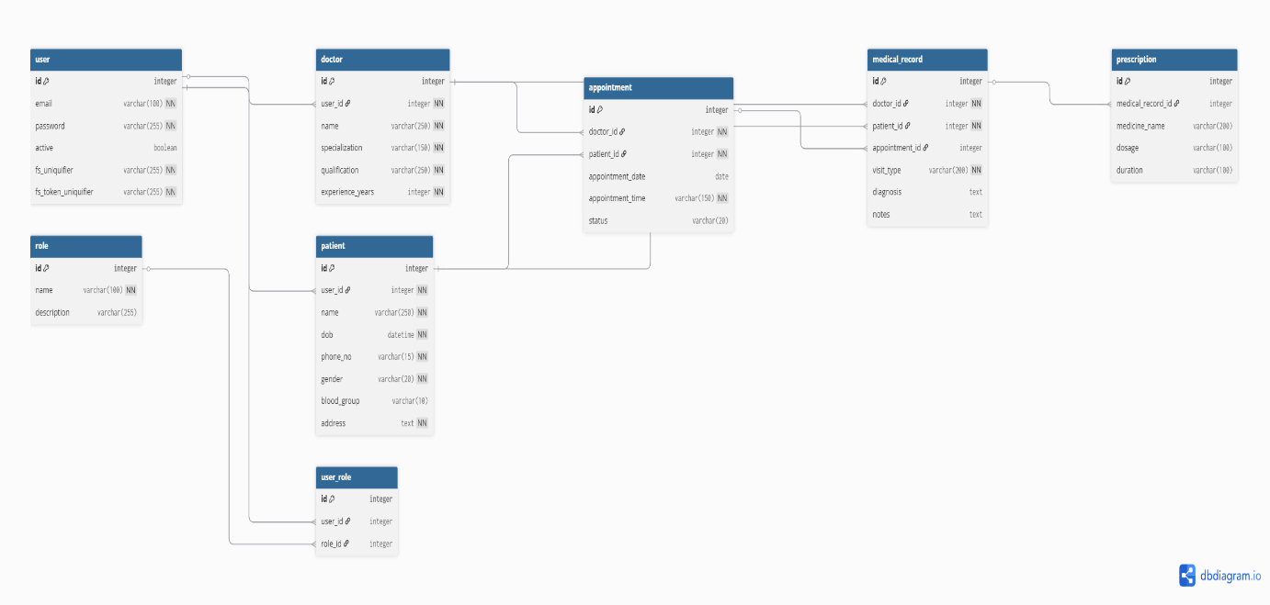

API Design
LoginApi,'/login' Login
BlackList,'/blacklist' Blacklisting Patient and Doctor
LogoutApi,'/logout' Logout user
RegisterApi,'/register' Register Doctor And Patient
DoctorList,'/doclist' List of Doctor
Delete,'/delete/<int:id>' Delete User
Deleteappoint,'/deleteappoint/<int:id>' Delete Appointment
DoctorEdit,'/docedit' Edit for Doctor
PatientEdit,'/patientedit' Edit for Patient
PatientList,'/patlist' List of Patient
PatientAppointment,'/patappointments' Appointment of Patient are Pending
YourAppointment,'/yourappointments' Appointment Based on role
AppointmentDone,'/appointmentsdone' Appointment that are completed
AppointmentData,'/appointment' Date of Appointmnet
UpdatePatient,'/updatepat' Update Patient
Name,'/name' Name on basis of Id
RecordPatient,'/recpat' Records of Patient
PatientHistory,'/pathis' History of patient
BookSlot,'/bookslot' To book slot
Ids,'/userid' Give user.id
Complete,'/comp' Commit medical_record andprescription
PatientFullRecord,'/patfullrec' Full record of Patient
ExportCSV, '/exportcsv' Export CSV file

Video
<<Link to your online video of not more than 3 minutes length>>

